Untitled
2026-07-16

Carga de datos
¿Cómo visualizamos los primeros datos del conjunto?
## , , Age = Child, Survived = No
##
## Sex
## Class Male Female
## 1st 0 0
## 2nd 0 0
## 3rd 35 17
## Crew 0 0
##
## , , Age = Adult, Survived = No
##
## Sex
## Class Male Female
## 1st 118 4
## 2nd 154 13
## 3rd 387 89
## Crew 670 3
##
## , , Age = Child, Survived = Yes
##
## Sex
## Class Male Female
## 1st 5 1
## 2nd 11 13
## 3rd 13 14
## Crew 0 0
##
## , , Age = Adult, Survived = Yes
##
## Sex
## Class Male Female
## 1st 57 140
## 2nd 14 80
## 3rd 75 76
## Crew 192 20
¿Como hacemos para saber de que tipo son los datos (texto/numero)?
str(Titanic)
## 'table' num [1:4, 1:2, 1:2, 1:2] 0 0 35 0 0 0 17 0 118 154 ...
## - attr(*, "dimnames")=List of 4
## ..$ Class : chr [1:4] "1st" "2nd" "3rd" "Crew"
## ..$ Sex : chr [1:2] "Male" "Female"
## ..$ Age : chr [1:2] "Child" "Adult"
## ..$ Survived: chr [1:2] "No" "Yes"

Including Plots
You can also embed plots, for example:
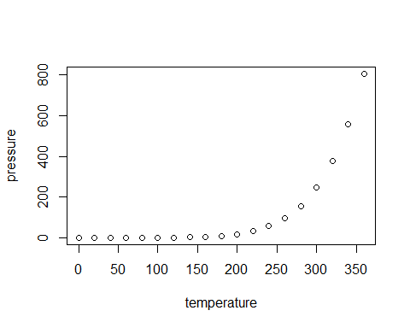
Note that the echo = FALSE parameter was added to the code chunk to prevent printing of the R code that generated the plot.

